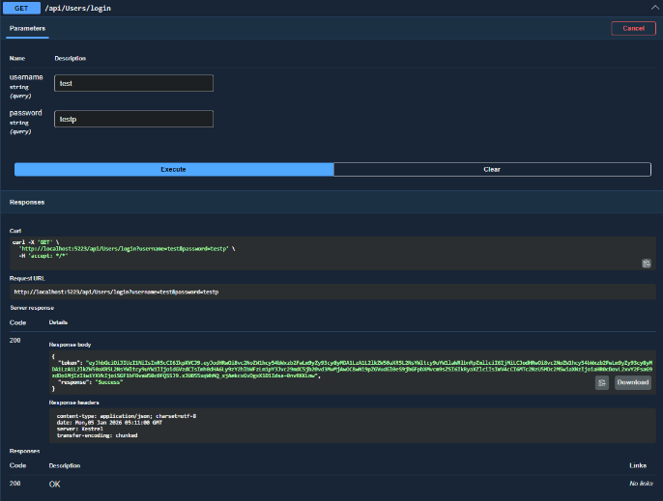
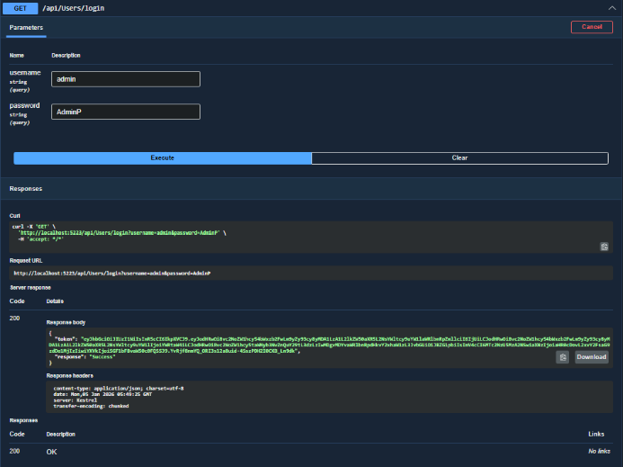Login: Example of a user of type driver(test user) and type Admin(admin user) both generate tokens and a login message
Case sensitive password
normalized username
Requirements
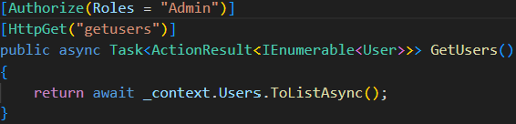
Result of User with Driver role(test) vs admin role (admin)
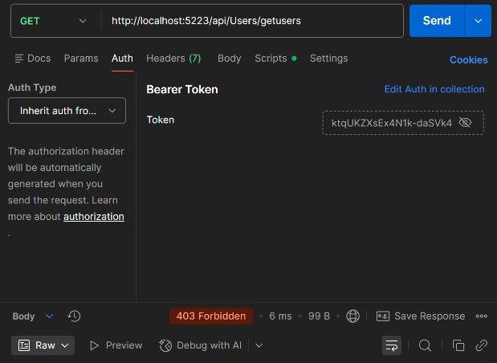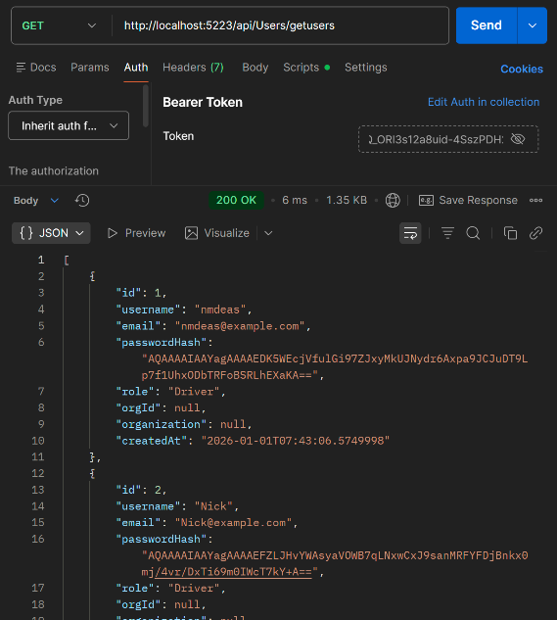

Login Page Logic:
The token needs to persist through refreshes
Token to be held in local storage
Token needs to be held in react state as well
Bugs:
User enters space in username and it return invalid username
Brute force password attempts

Random:
Inline conditional
if-else var ? opt1 : opt2
notes to elaborate on:
regex[input validation] refer to registration page
not sharing validation feedback on signin[don’t use username not found]
flex-shring + flex-grow refer to authlayout for left and right
react layouts very helpful for reducing repetitive code
recognize shared css, saved a lot of repetition
parent and child information sharing refer to login token passing
try catch[ex token.parsing to check for format]

Rememnber this command for out of bounts formatting: document.querySelectorAll('*').forEach(el => { if (el.offsetWidth > document.documentElement.offsetWidth) { console.log('Found it:', el); el.style.outline = '2px solid red'; } });

02/10/26
I need more understanding of sizing and what units to use for what px.vh,vw,rem,em I am all over the place with styling, I feel I am using systems of measurement with no good reason
Typography: rem
Spacing: rem
Component scaling: em
Layout sizing: %, vh, vw
Borders/shadows: px
this is the system I want to stick to from here on out and once I get more comfortable with that I can go back and correct my inefficient styling

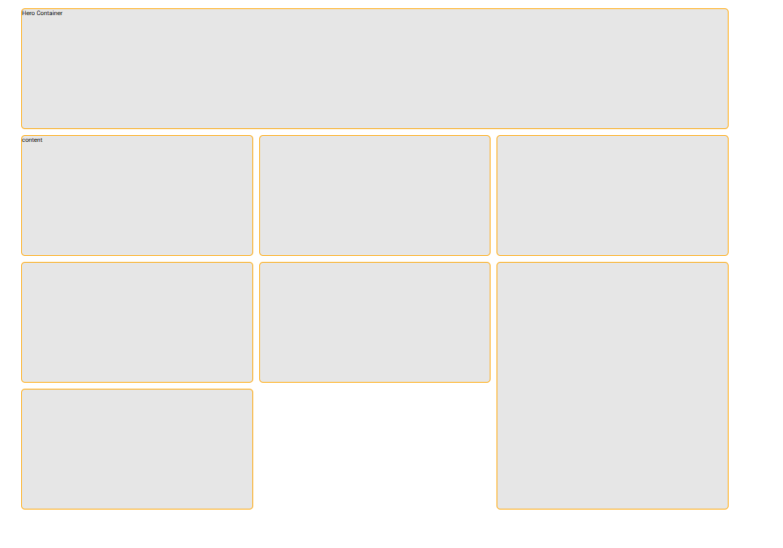

Accounts:
Driver:
Username
Email
Password
Admin
Username
Email
Password

